**Q1: Sector Trend Movements**

After we calculated the percent decline and percent value retention (VR), we applied weighted average value retention according to the market capitalization of each company in order to measure the sector performance. Based on our results (Table 1.1), the weighted VR of Consumer Staples is 76.50%, while the weighted VR of Consumer Discretionary is 68.83%. Consumer Staples sector contains basic necessities such as Packaged Foods & Meats, Soft Drinks, Agricultural Products, etc. These kinds of products have low income elasticity of demand and tend to have a stable price during an economic crisis. On the opposite, Consumer Discretionary including many luxury goods has much lower income elasticity of demand. Therefore, Consumer Staples has the highest weighted VR in our table while Consumer Discretionary shows lower strength in value retention. This observation is consistent with the rules of Income Elasticity of Demand.

**Table 1.1** Sector performance

|  |  |  |  |
| --- | --- | --- | --- |
| GICS Sector | Weighted VR | Average VR | Percentage Decline |
| Consumer Staples | 76.50% | 74.53% | -25.47% |
| Health Care | 72.11% | 69.89% | -30.11% |
| Communication Services | 70.97% | 66.33% | -33.67% |
| Information Technology | 69.34% | 66.58% | -33.42% |
| Consumer Discretionary | 68.83% | 52.29% | -47.71% |
| Utilities | 63.93% | 63.18% | -36.82% |
| Materials | 63.25% | 61.32% | -38.68% |
| Real Estate | 60.95% | 57.60% | -42.40% |
| Industrials | 57.78% | 58.50% | -41.50% |
| Financials | 57.15% | 54.69% | -45.31% |
| Energy | 44.29% | 39.73% | -60.27% |

However, the Consumer Discretionary seems more immune in this crisis than some essential sectors like Utilities and Materials. Focusing on the exact average VR, we actually can see that Consumer Discretionary has much lower average VR than the other two sectors. The reason of this inconsistency, in our hypothesis, is that some big companies with large market capital in the Consumer Discretionary sector are relatively immune in Coronavirus pandemics. Digging deeper in our dataset, we found that companies like Amazon and Target had very large Market Cap and high VR in this crisis, where Amazon has the largest Market Cap in Consumer Discretionary sector with high retention value of 89.13%. Similarly, the VR of Target Corp. reached 82.90% with over 59 billion Market Cap. It makes sense because Amazon and Target represent Internet Retail companies, who can continue their business and needless to say more immune to the global quarantines. Therefore, these large companies with high economical immunities contributed a lot to the weighted VR and caused the inconsistency between average VR and weighted VR.

**Q2: A Deadly Crash in Energy Sector**

It is very obvious that the weighted VR of Energy sector is the lowest and much lower than any other sectors. In Energy sector, most companies’ main business is related to oil. Unfortunately, oil price crashed as Arabia and Russia vowed to pump more in a battle for market share. The all-out price war between these two countries caused futures slumped by about 25% at the beginning of March. No oil related companies can hide from these extreme price falls (Figure 2.1). In particular, explorers including Occidental Petroleum Corp. and Parsley Energy Inc. planning drilling cuts. These passive expectations will lead to a predictive fall of share price. In our case, the VR of Occidental Petroleum is merely 23.29%.

**Figure 2.1** WTI crude price (Feb. 14th – Mar. 23rd)

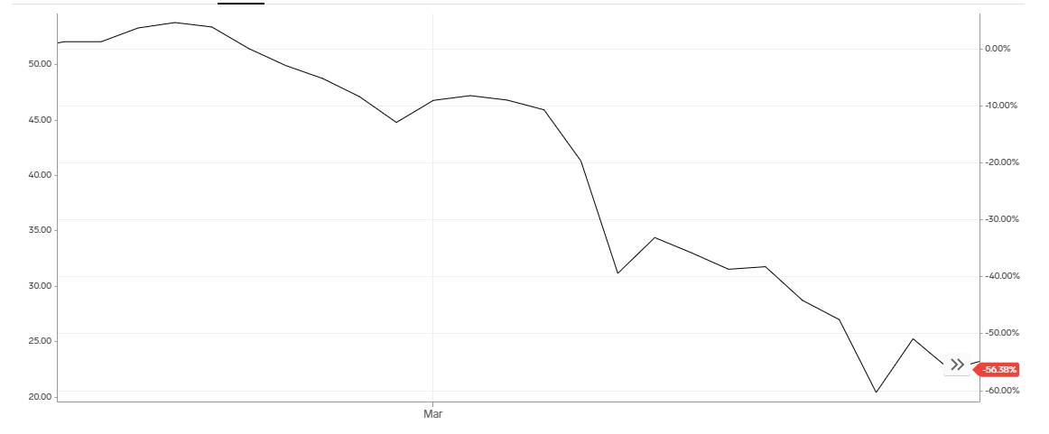

What’s more, the higher cost of producing shale oil makes US companies vulnerable to prolonged price wars. According to consultancy Rystad Energy, just 16 U.S. shale companies operate in fields where the average new well costs are below $35 per barrel. Most of the shale producers had expectations for oil between $55 and $65 per barrel in 2020, so the price fall puts them in a very dangerous point that they will not be able to shoulder their high debt load. Due to these reasons, few investors could be confident in the energy corporations, and it is foreseeable that slumped share price and the shrinkage of retention value.

**Q3: Financial Sector Crash**

Although it is not as severe as what happened in the energy industry, the financial sector has faced a similar dangerous inability in value retention during these global events. Facing this outside shock, Federal Reserve try to limit damage and promote recovery in several ways. One of the most important actions is to lower its target interest rate by a full percentage point nearly to zero and provide guidance that rates would remain at this level until the economy is confident to weather the events. The Fed has not taken such drastic actions since the Great Financial Crisis. This monetary policy could boost the currency liquidity and support the flow of credit to households and businesses which aims to help the economy to recover. However, the downside is that the banking systems will have much lower profit due to the low interest rates. Although the Fed has reduced banks’ reserve requirements to zero in order to encourage banks to extend loans, the requirements were already very low that this action will not be as useful as expected.

As a result, with the low interests, the money is so readily available and so cheap but because of COVID-19, this action could not draw people back to work and to shopping. Instead, financial institutes who make money from the interest rate on the loans and credit card debts, for example commercial banks, have to lower their expectations and their share price will accordingly be damaged. The Fed is doing its job to keep the financial system to meet the need of economy but it will not take effect until the society get confident in addressing this global health problem. The low interest rates did not address the root cause of the problem but partly contributed to a financial sector crash instead.